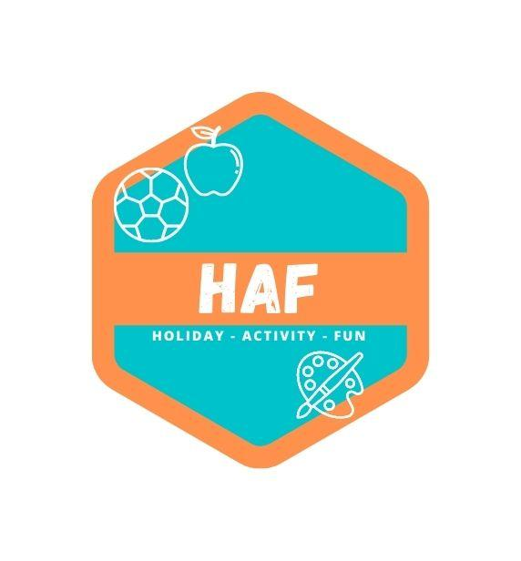
Child Behaviour Policy
Our detailed child behaviour policy is followed by staff at all times and is located on the site of each West Lancs HAF Camp. This is a separate document available to staff only.
All stages are to be communicated to each child who is going through this process as they reach each stage, making our guidelines clear.
Continuous risk assessing
Stage 1 – Verbal Warning
The child is brought to one side by staff, warned verbally, and then allowed to continue with the activity.
Stage 2 – Second Verbal Warning
This a second warning for a Stage 1 action. The child in question will be reminded of behaviour expectations and be warned that the next stage will be for them to be removed from the session.
Stage 3 – Removal
This involves the child being removed from an activity to speak 1-2-1 with a member of staff. The child and the member of staff will agree on what needs to happen to allow the child to continue to take part in the session. Failure to meet the agreed points will result in the child being removed for the remainder of the activity.
Stage 4 – Contact Parent
Despite several warnings and agreed behaviour expectations, the child continues to be disruptive, uncooperative and potentially a danger to themselves and other children. In this case, we will contact parents to make them aware of the issues that have taken place that day.
If the child refuses to communicate with staff, they will be offered the chance to speak to their parent on the phone in an attempt for them to improve their behaviour.
Stage 5 – Child Collected from Camp

This policy was adopted by: West Lancs HAF | Date: 20/03/2023
Reviewed on: 21/06/25  To be reviewed: 21/06/26 | 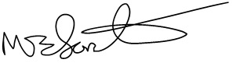  Signed: M.Forster

